# Software Requirements

# Software Requirements Specification (SRS)

Revision History:

|  |  |  |
| --- | --- | --- |
| Date | Author | Description |
| 20-9-19 | Sail | create the document |
| 20-10-6 | Zachary | perfect the document |
| 20-10-23 | Zachary | modify the use case diagram |
|  |  |  |

Contents

Software Requirements

Software Requirements Specification (SRS)

1.  Introduction

1.1    Intended Audience and Purpose

1.2    How to use the document

2.  Concept of Operations

2.1    System Context

2.2.  Use Cases

3.    Behavioral Requirements

3.1 System Inputs and Outputs

4.   Quality Requirements

5.    Fundamental Assumptions

6.    Expected Changes

7.    Appendices

7.1    Definitions and acronyms

7.2    References

## 1.  Introduction

### 1.1    Intended Audience and Purpose

Our team's work is to develop the android side and WeChat miniprogram side of the "X-ray detection of spinal kyphosis" system. This document aims to list all the needs of patients, their families and doctors who may use the system.The following entities may find the document useful:

* Primary Customer - This page will detail all of the application requirements as understood by the production team. The customer should be able to determine that their requirements will be correctly reflected in the final product through the information found on this page.
* User - A prospective user will be able to use this document to identify the main function included in the application. Furthermore, the application will have a set of system requirements before the application can be run. Details regarding these requirements can be found here.
* Development Team - Details of specific requirements that the final software build must include will be located here. Developers can use this document to ensure the software addresses each of these requirements.
* QA Team - By developing testing procedures founded in the system requirements, the QA Team can create a comprehensive testing regimen that will guarantee requirements are met.

### 1.2    How to use the document

Table of Contents:  
1. Introduction  
2. Concept of Operations - broad description of the purpose of the application  
  2.1 System Context - details any specific system requirements the application will require to run  
  2.2 Use cases - A detailed look at each functional requirement, describing the application context both before and after an action is taken  
3. Behavioral Requirements - How the application will interact with a user  
  3.1 Input and output requirments - A description of allowed inputs and generated outputs  
    3.1.1 Input - Describes any restrictions that will be placed on allowed input  
    3.1.2 Output - Describes the range of outputs that can be generated  
  3.2 Detailed Output Behavior - Output descriptions in prose  
4. Quality Requirements - Requirements not pertaining to the function of the application will be listed here  
5. Fundamental Assumptions - Some specifics about input, output, or behavior upon which other requirements are founded will be listed here  
6. Expected Changes - Future features and directions the project is expected to take  
7. Appendicies - Details aiding the understanding of this document  
  7.1 Definitions and acronyms - Any technical terms or abbreviations will be spelled out here for ease of use of the document  
    7.1.1 Definitions - Definitions of technical or unusual terminology  
    7.1.2 Acronyms and Abreviations - Any abreviated terms will be expanded here  
  7.2 References - any external references necessary or helpful to understanding this document will be listed here

## 2.  Concept of Operations

The goal is to create a user-friendly application.It will allow users to use our algorithm engine to detect scoliosis through X-ray image recognition, as well as allow doctors to manually modify the algorithm's results.Patients and their families do not need to install any app, just open the small program directly in WeChat to use.Doctors need to install the app before using it.

### 2.1    System Context

**System Requirements:**  
WeChat small program:

1. Small program terminal is only for non-professional users such as family members

2. Applets are limited to mobile phones without considering other screen sizes

3. Users need WeChat client support of iOS 6.5.8 / android 6.5.7 or above

Android:

1. Andorid is only for professional users such as doctors, and is only used within professional institutions such as hospitals

2. Android terminal devices are limited to large-screen Android tablet devices, and mobile phone adaptation is not required

3. The device requires Android 6.0 or above

2.2.  Use Cases

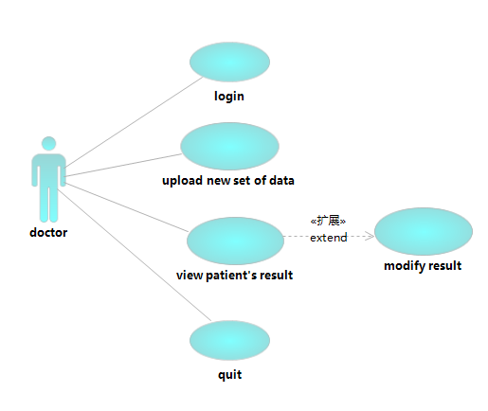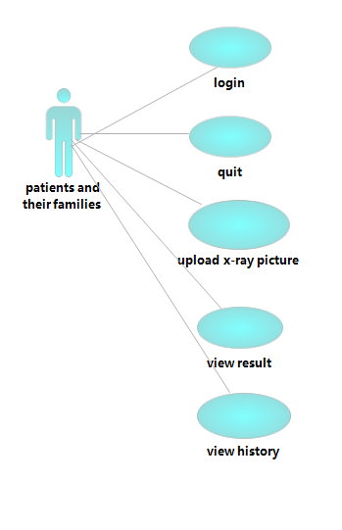Use case diagram

#### Case 1: Users want to login

**Players:patients and their families**

**Goals:**Users need to log into the system to see relevant information  
**Preconditions:**Users need WeChat client support of iOS 6.5.8 / android 6.5.7 or above  
**Case:**  
1.1 The user opens the wechat

1.2 Slide down, find the applet and open it.

1.3 The user input his or her own user id and password, then click enter button.

**Alternate Flows:**  
**Exception Flows:**  
1.1.1 ios or Android versions are too low  
         The client does not display correctly.

1.3.1 The user id doesn’t exist or wrong password.

The user can’t login success.  
**Postconditions:**The client is open and running, waiting for its next instruction from the user.

#### Case 2 Users want to login

**Players: doctors**

**Goals:**Users need to log into the system to manually modify the algorithm's results  
**Preconditions:**Android terminal devices are limited to large-screen Android tablet devices, and mobile phone adaptation is not required. Users need to install the app. Also, The device requires Android 6.0 or above.

**Case:**  
1.1 The user opens the app

1.2The user input his or her own user id and password, then click enter button.

**Alternate Flows:**  
**Exception Flows:**  
1.2.1 Android versions are too low  
         The client does not display correctly.

1.2.2 The user id doesn’t exist or wrong password.

The user can’t login success.  
**Postconditions:**The client is open and running, waiting for its next instruction from the user.

#### Case 3: User Wants to Use Scoliosis Detect Algorithm Engine

**Players:**  Patients and their families

**Goal:** The user would like to use scoliosis detect algorithm engine and acquire a true answer.    
**Preconditions:** The client is open and login.  
**Case**:

1.1 The user chooses which scoliosis detect algorithm engine they want to use.

1.2 The user clicks upload image button.

1.3 The user uploads correct x-ray photo when file select window has opened.  
1.4 The user clicks submit button.

1.5 The web client displays result and user acquire information they need.

**Alternate Flows**:  
**Exception Flows:**  
1.3.1 The image user upload isn’t qualified x-ray photo.

The client shows a warning message and user can upload photo again.

**Postconditions:**The client can display result which from server.

#### Case 4: Doctors Wants to Upload a New Set of Data

**Players:**  Doctors  
**Goal:** The user would like to upload a new set of data to train our scoliosis detect algorithm engine.    
**Preconditions:** The client is open and login.  
**Case**:

1.1The user clicks upload data button.

1.2The user uploads a zip of new data.

1.3The user clicks submit button.

1.4The web client displays success message.

**Alternate Flows**:  
**Exception Flows:**

**1.2.1 The user uploaded data in the wrong format**

The client issues a warning and the user can reupload the data

**Postconditions:**The new set of data can be sent to the server.

#### Case 5: User Wants to View Previous Scoliosis Detect Result

**Players**:patients and their families

**Goals:**The user wants to see previous scoliosis detect result.  
**Preconditions:** The client is open and running.

**Case:**   
1.1 From the result records menu, the end user selects the which record he or she want to see.   
1.2 The client display correspondingly scoliosis detect result.  
**Alternate Flows:**  
**Exception Flows:**  
**Postconditions:**

#### Case 6: User Wants to View Previous Scoliosis Detect Result

**Players**: doctors

**Goals:**The user wants to see previous scoliosis detect result of patients.

**Preconditions:** The client is open and running.

**Case:**   
1.1 input the id number of the patient

1.2 From the result records menu, user selects which record he or she want to see.   
1.3 The client display correspondingly scoliosis detect result.  
**Alternate Flows:**  
**Exception Flows:**

1.1.1 the id number doesn’t exist, or the id number is wrong

The client issues a warning and the user can input the id again

**Postconditions:**

#### Case 7: Doctors Wants to manually modify the algorithm's results

**Players:**  Doctors  
**Goal:** The doctor manually modifies (fine-tunes) the position of the auxiliary wire   
**Preconditions:** The client is open and login.  
**Case**:

1.1The user open correspondingly scoliosis detect result with Position information such as terminal vertebral coccyx, and Cobb Angle

1.2The user modifies the position of the auxiliary wire.

1.3The client recalculate the angle.

1.4The client displays modified result.

**Alternate Flows**:  
**Exception Flows:**

**Postconditions:**The modified angle can be calculated.

#### Case 8: User Wants to Quit and Close the Web Client

**Players: patients and their families,doctors.**

**Goals:**The end user wants to quit and close the client.

**Preconditions:**The client is open and login.  
**Case:**  
5.1 From the menu, the end user selects the "Close all and Quit" option.  
5.2 The application terminates itself.  
**Alternate Flows:**  
**Exception Flows:**  
**Postconditons:**

## 3.    Behavioral Requirements

### 3.1 System Inputs and Outputs

#### 3.1.1 Inputs

Wechat client(Users:patients and their families),The user can select the following options: “login”,”quit",”upload”,”view previous results”. Mainly input is X-ray photo.

Android client(Users:doctors),the user can select the following options:”login”,”quit”,”view results”.And when user views results they can also modify the result.

#### 3.1.2 Outputs

Mainly result is Marked X-ray chart and angle of scoliosis.

## 4.   Quality Requirements

The application must be competitive with similar applications in regards to performance, reliability, consistency, and scalability.

## 5.    Fundamental Assumptions

WeChat small program:

1. Small program terminal is only for non-professional users such as family members

2. Applets are limited to mobile phones without considering other screen sizes

3. Users need WeChat client support of iOS 6.5.8 / android 6.5.7 or above

Android:

1. Andorid is only for professional users such as doctors, and is only used within professional institutions such as hospitals

2. Android terminal devices are limited to large-screen Android tablet devices, and mobile phone adaptation is not required

3. The device requires Android 6.0 or above

## 6.    Expected Changes

   Features to Add:

User Defined Fields

Doctors verify detect results  
      Links to Social Media

   Future Platforms:

## Appendices

### 7.1    Definitions and acronyms

#### 7.1.1    Definitions

|  |  |
| --- | --- |
| **Keyword** | **Definitions** |
|  |  |

#### 7.1.2    Acronyms and abbreviations

|  |  |
| --- | --- |
| **Acronym or**  **Abbreviation** | **Definitions** |
| ios | iphone operating system |
| Android | Android system |

### 

### 7.2    References